**ClearSale**

***Version 19.1.0***



**Table of Contents**

1. Summary 3

2. Component Overview 4

2.1 Functional Overview 4

2.2 Use Cases 5

2.3 Limitations, Constraints 6

2.4 Compatibility 6

2.5 Privacy, Payment 6

3. Implementation Guide 7

3.1 Setup 7

3.2 Configuration 7

3.2.1 Business Manager Configurations 7

3.2.2 Importing Metadata 7

3.2.3 Custom Site Preferences 8

3.2.4 Services Configurations 8

3.2.5 Job Configurations 9

3.3 Custom Code 11

3.4 Firewall Requirements 11

4. Operations, Maintenance 11

4.1 Availability 11

4.2 Support 12

5. User Guide 12

6. Known Issues 13

7. Release History 13

_Toc280189048

_Toc280189048

# Summary

This integration cartridge is built to connect online ecommerce stores to the ClearSale Fraud Prevention Solution. After this integration, ClearSale will provide decisions about the orders that have been placed in your store.

# Component Overview

## Functional Overview

ClearSale reduces the number of false declines that can cost sales and customer relationships. To make this happen the orders placed on the storefront are exported to ClearSale using the integration cartridge. These orders are processed and a status is sent back to the store based on which the store can get more insights on the order.

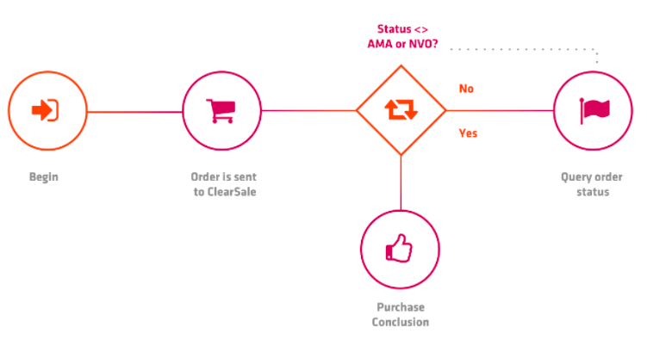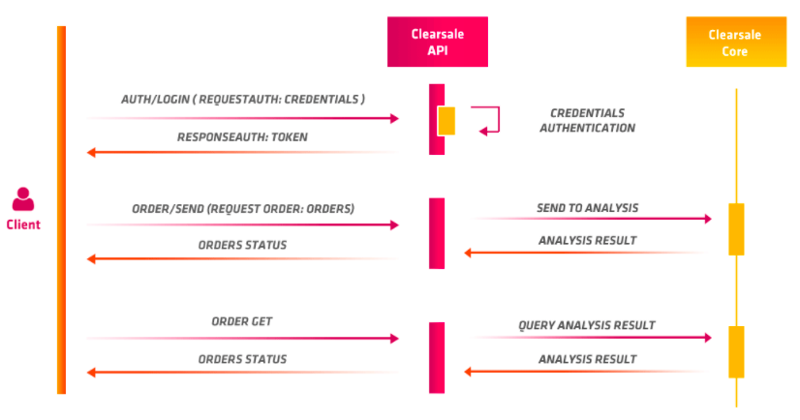

## Use Cases

Once finished all configuration, please set the environment to the sandbox.

We recommend you to perform the following tests:

* Place an order with the value more than 100,00 the ClearSale Status should be ‘Analyzing’.
* Place an order with the value between 50,00 and 100,00 the ClearSale Status should be ‘Reproved’.
* Place an order with the value less than 50,00 the ClearSale Status should be ‘Approved’.

To check the orders in ClearSale environments follow the steps below:

**Note:** Your sandbox client id is your user and the client secret is your password.

1. Look for search order on the <https://app.clear.sale> for production and <https://sandbox.clear.sale> for sandbox

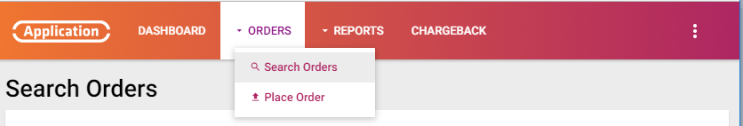

1. Search the order by number or data.

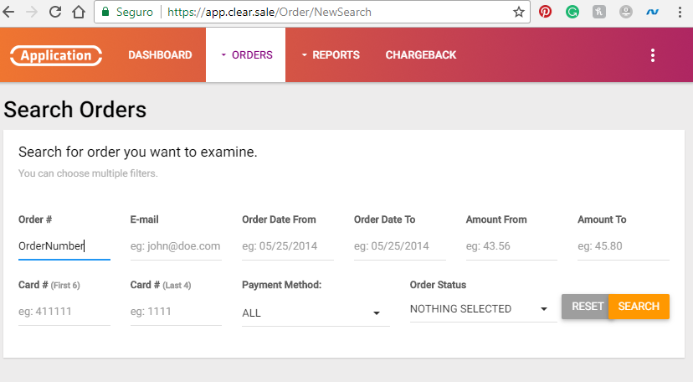

1. Check if the order is on the clearsale app.



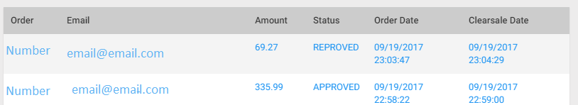

## Limitations, Constraints

To understand more about the ClearSale platform please visit:

<https://www.clear.sale/developers/api#integration-flow/>

## Compatibility

The cartridge was developed on the SiteGenesis version 104.1.3 of the Salesforce Commerce Cloud Platform. During the development and testing of the cartridge the Compatibility Mode was always set to 18.10

## Privacy, Payment

The customer information appearing on the order is sent to ClearSale. Credit cards numbers are taken from the masked information that is provided by the platform.

# Implementation Guide

## Setup

The first and the most important step is to deploy the cartridges on staging along with the storefront code. After that it must be configured in the effective cartridge path.

## Configuration

To complete the integration of the cartridge the following configuration are to be made to Salesforce Commerce Cloud Business Manager for seamless execution of cartridge:

## Business Manager Configurations

* + 1. Once the uploading of the is completed, login to Business Manager (BM) and go to Administration - > Sites - > Manage Site
    2. Click on the link Business Manager Site
    3. See “Cartridges” text field containing a “:” colon separated list of cartridge names.
    4. Type “int_clearsale” followed by colon ‘:’ at the end of the list and press “Apply” button. If this is the only cartridge there is no need to put a colon at the end.
    5. Once it is configured the name of the cartridge will appear in the “Effective Cartridge Path” as shown and will be ready for use.

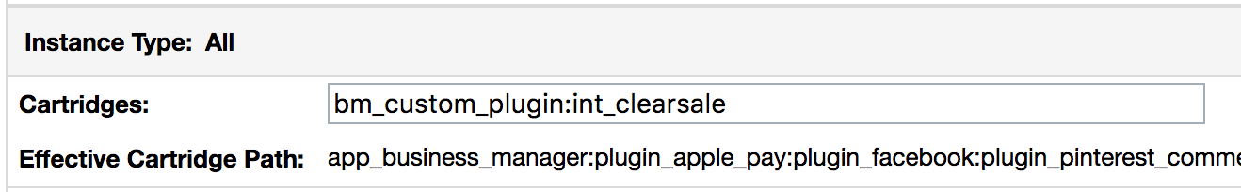

## Importing Metadata

1. To do that, zip the ***site_template*** folder under sites to a file called **site_template.zip**
2. Log in to Business Manager and then go to Administration > Site Development > Site Import & Export
3. Upload the site_template.zip file and once it is uploaded select it from the list and hit the import button.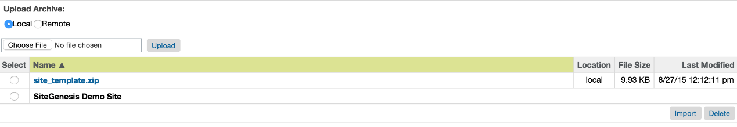

## Custom Site Preferences

1. To set the custom site preferences with the preferred values go to Merchant Tools > Site Preferences > Custom Preferences

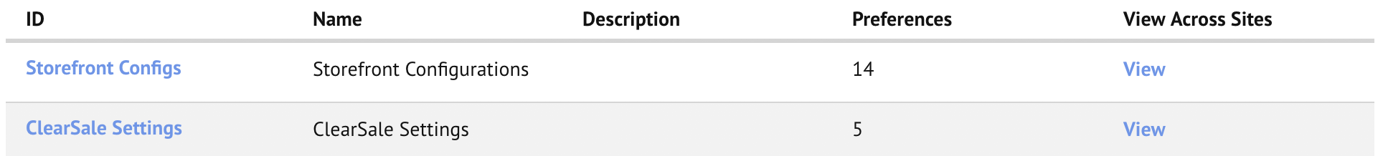

1. Click on ClearSale Settings then a list of site preferences will be displayed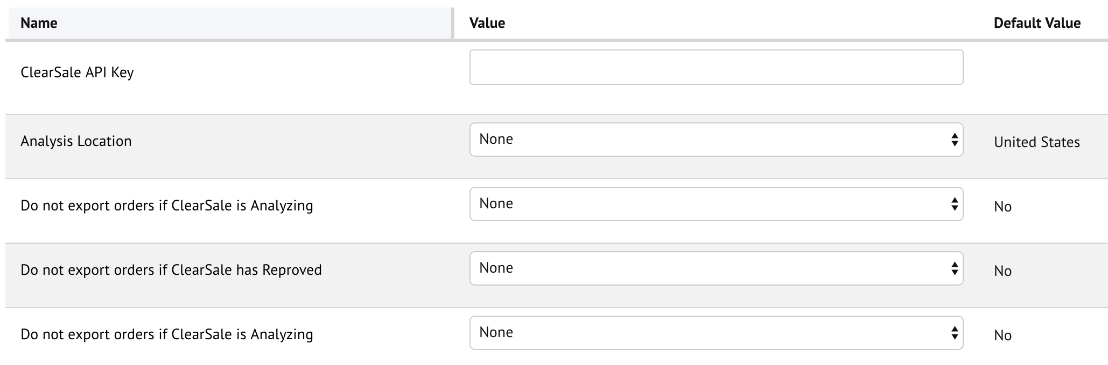
2. Configure the API Key provided by ClearSale

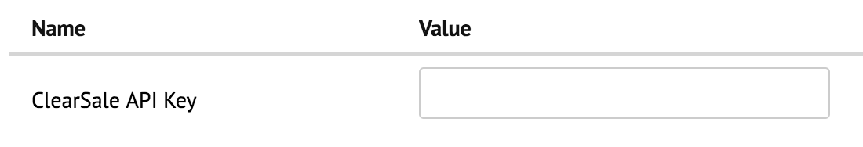

1. Appropriately set the values of the other settings

|  |  |  |
| --- | --- | --- |
| Preference | Values | Description |
| Do not export orders if ClearSale is Analyzing | Yes/No Default: No | If set to ‘Yes’, the NOT_EXPORTED status will be set on the order |
| Do not export orders if ClearSale has Reproved | Yes/No Default: No | If set to ‘Yes’, the NOT_EXPORTED status will be set on the order |
| Cancel order if ClearSale has Reproved | Yes/No Default: No | If set to ‘Yes’, the order will be cancelled |

## Services Configurations

1. Go to Administration > Operations > Services and you should be able to see the service for Clearsale. However, during import the credentials are not copied by Commerce Cloud due to security reasons therefore you will have to put the right credentials.

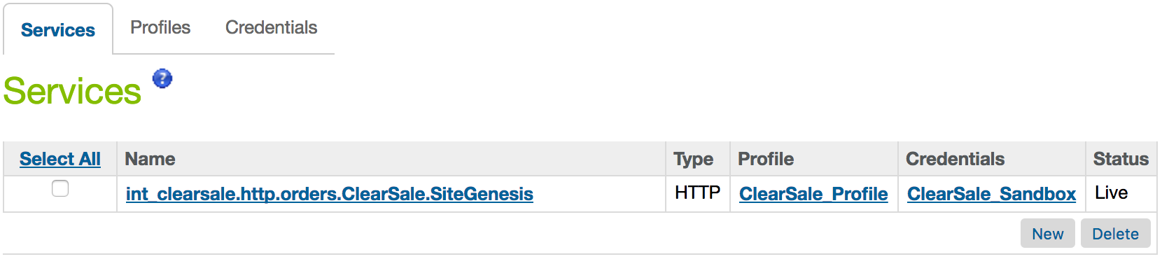

1. Click on the credentials Tab and you will see credentials for Production and Sandbox

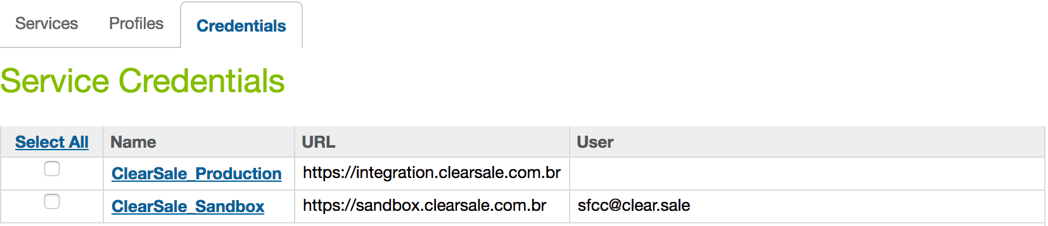

1. Click on the name of the credentials for which you want to change the value.
2. Put the correct user and password for the environment on which you want to test and click the apply button.

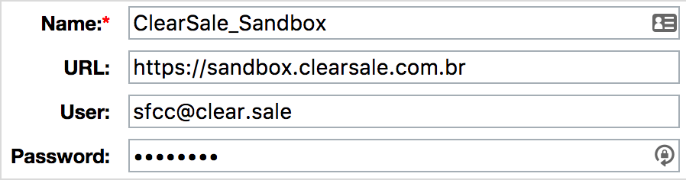

1. In case you want to switch between LIVE and SANDBOX credentials you have to go to the Services Tab again and click the name of the service.
2. Select the Credentials that you want to apply for this service and click Apply button.

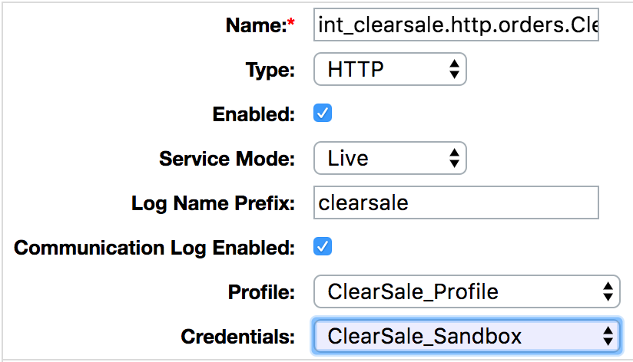

## Job Configurations

1. For configuring jobs go to Administration > Operations > Job Schedules and here you should be able to see two jobs

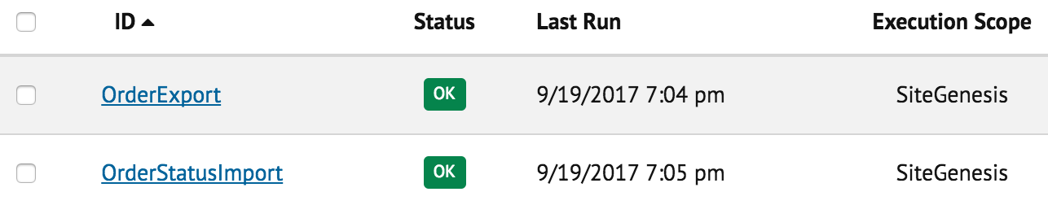

1. Make sure that the Execution scope of the jobs match your storefront site
2. If it does not match, click on each of the jobs and go to Step Configurator

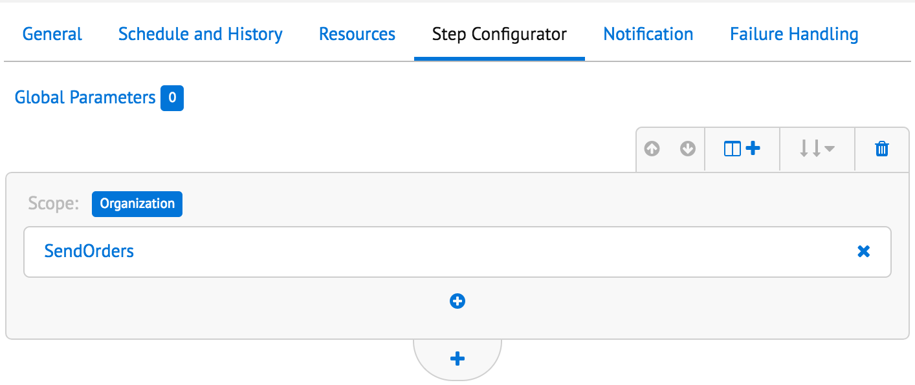

1. Click on the blue button in front of the Scope label and you will see a list of available sites to choose. Choose the site for which you want to run the job and click assign.

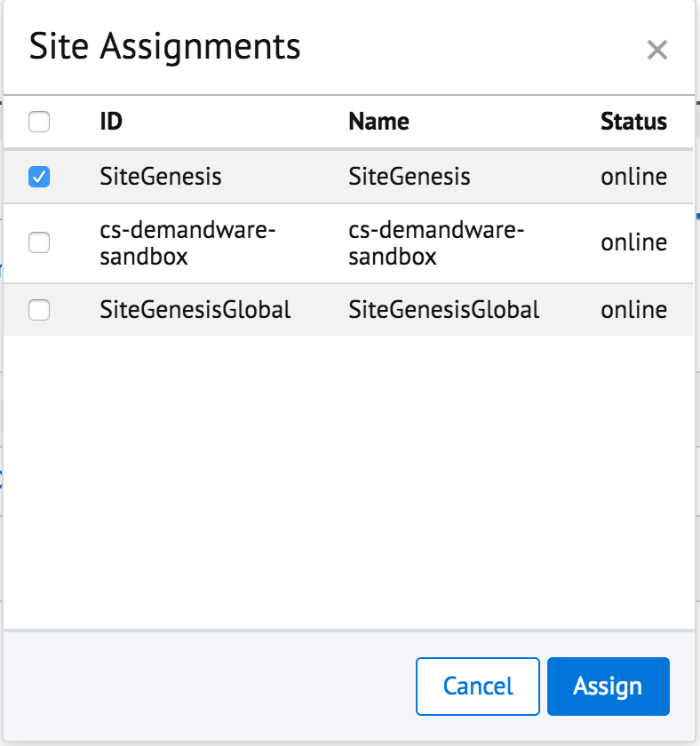

1. To configure the job schedules go back to Administration > Operations > Job Schedules and here you should be able to see two jobs



1. Click on OrderExport and go to Schedule and History Tab.
2. Do the following steps to configure the job.
3. Select the From date to be the current date.
4. Leave the To date empty (so the job has no end date)
5. Set the Run Time to be Every Amount 10 and Interval Minutes (so that the export job runs every 10 mins
6. Select all days from Run on these days so the job runs every
7. Do not forget to Enable the job by clicking the checkbox on the top as shown below.

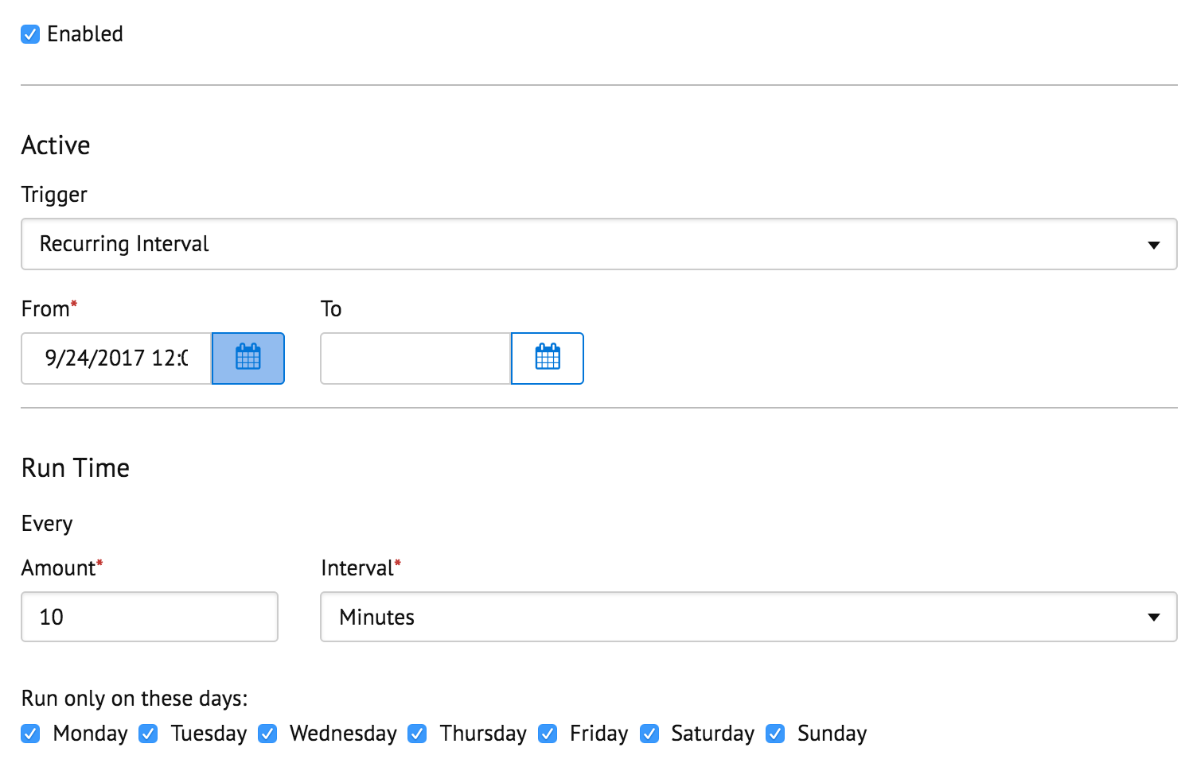

1. Click on OrderStatusImport and go to Schedule and History Tab.
2. Do the following steps to configure the job.
3. Select the From date to be the current date.
4. Leave the To date empty (so the job has no end date)
5. Set the Run Time to be Every Amount 10 and Interval Minutes (so that the export job runs every 10 mins
6. Select all days from Run on these days so the job runs every
7. Do not forget to Enable the job by clicking the checkbox on the top as shown below.



## Custom Code

There are no changes required in the storefront code to integrate this cartridge.

## Firewall Requirements

There is no need to get the IP of the service whitelisted as the communication is based on standard http ports.

# Operations, Maintenance

## Availability

The services of ClearSale are expected to run at all times but if you have any issues please feel free to contact support at the addresses provided below.

The Clearsale integration don't affect the checkout process even though the service is unavailable. The job will fail and as soon as Clersale is back the orders will be updated with the clearsale decision.

## Support

If you experience an issue and would like to connect to us, you can reach us on the following email address.

[support@clear.sale](mailto:support@clear.sale)

For questions about the integration process feel free to contact at the following email address.

[integration@clear.sale](mailto:integration@clear.sale)

If you need credentials to access our system please fill the form at:

<https://clear.sale/getstarted>

# User Guide

If you want to check the status of the order returned by ClearSale in Business Manager, follow the steps provided below:

1. Navigate to Merchant Tools > Ordering > Orders
2. Search/Open the order for which you want to know the status
3. Click on the ‘Attributes’ tab
4. You should see the status under ‘ClearSale Status’ field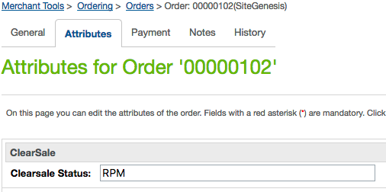
5. In Commerce Cloud, the status can be one of the following:

|  |  |
| --- | --- |
| Status | Description |
| NVO | New |
| APM | Approved |
| CAN | Cancelled by Client |
| RPM | Denied |

# Known Issues

At the moment there are no known issues in the cartridges and there are no limitations.

# Release History

|  |  |  |
| --- | --- | --- |
| **Version** | **Date** | **Changes** |
| 17.1.0 | 01-Oct-2017 | Initial release |
| 18.1.0 | 01-Oct-2018 | Enhancements and bug fixes |
| 19.1.0 | 31-July-2019 | Enhancement |